LAB ASSIGNMENT -1
BY :- Harshita , Rollno :- 2505010044
Q1)
// Menu driven program to display the following array operations
//MENU
//CREATE , DISPLAY , INSERT , DELETE , LINEAR SEARCH , EXIT
#include <iostream>
using namespace std;
int main() {
int arr[100], n = 0; // array and size
int choice;
do {
cout << "\n---- MENU ----\n";
cout << "1. CREATE\n";
cout << "2. DISPLAY\n";
cout << "3. INSERT\n";
cout << "4. DELETE\n";
cout << "5. LINEAR SEARCH\n";
cout << "6. EXIT\n";
cout << "Enter your choice: ";
cin >> choice;
if (choice == 1) {
cout << "Enter number of elements: ";
cin >> n;
cout << "Enter " << n << " elements:\n";
for (int i = 0; i < n; i++) {
cin >> arr[i];
}
cout << "Array created.\n";
}
else if (choice == 2) {
if (n == 0) cout << "Array is empty.\n";
else {
cout << "Array elements: ";
for (int i = 0; i < n; i++) {
cout << arr[i] << " ";
}
cout << endl;
}
}
else if (choice == 3) {
int pos, val;
cout << "Enter position to insert (1 to " << n+1 << "): ";
cin >> pos;
cout << "Enter value: ";
cin >> val;
if (pos < 1 || pos > n+1) {
cout << "Invalid position!\n";
} else {
for (int i = n; i >= pos; i--) {
arr[i] = arr[i-1];
}
arr[pos-1] = val;
n++;
cout << "Value inserted.\n";
}
}
else if (choice == 4) {
int pos;
cout << "Enter position to delete (1 to " << n << "): ";
cin >> pos;
if (pos < 1 || pos > n) {
cout << "Invalid position!\n";
} else {
for (int i = pos-1; i < n-1; i++) {
arr[i] = arr[i+1];
}
n--;
cout << "Value deleted.\n";
}
}
else if (choice == 5) {
int key, found = 0;
cout << "Enter value to search: ";
cin >> key;
for (int i = 0; i < n; i++) {
if (arr[i] == key) {
cout << "Value found at position " << i+1 << ".\n";
found = 1;
break;
}
}
if (!found) cout << "Value not found.\n";
}
else if (choice == 6) {
cout << "Exiting program...\n";
}
else {
cout << "Invalid choice!\n";
}
} while (choice != 6);
return 0;
}
OUTPUT

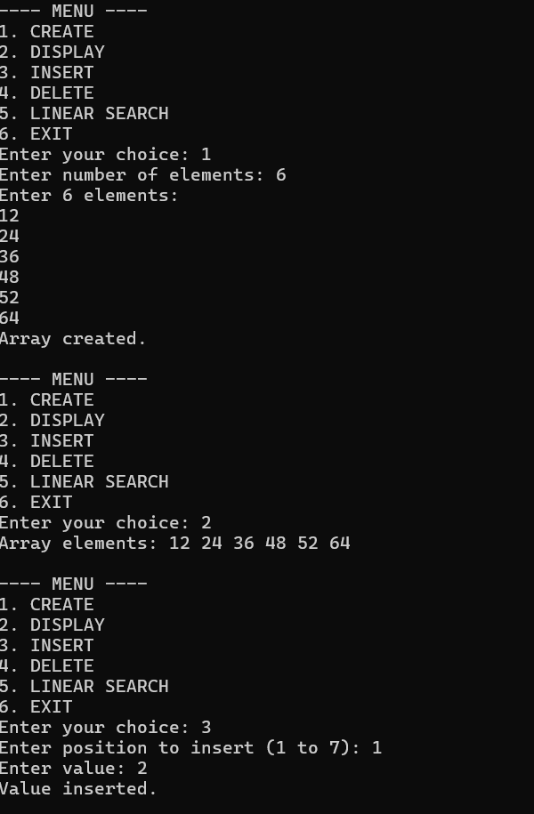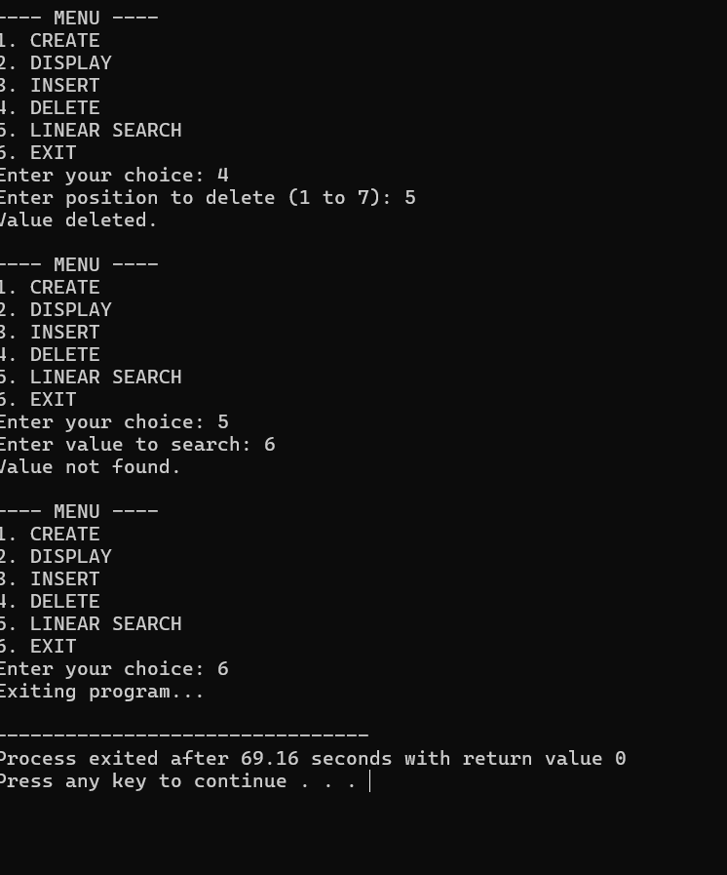
Q2)
//Program to delete vowels from the string
#include <iostream>
using namespace std;

bool isVowel(char ch) {
return (ch == 'a' || ch == 'e' || ch == 'i' || ch == 'o' || ch == 'u' ||
ch == 'A' || ch == 'E' || ch == 'I' || ch == 'O' || ch == 'U');
}

int main() {
string str, result;

cout << "Enter a string: ";
getline(cin, str);

for (size_t i = 0; i < str.length(); i++) {
if (!isVowel(str[i])) {
result += str[i];
}
}

cout << "String after deleting vowels: " << result << endl;

return 0;
}
OUTPUT
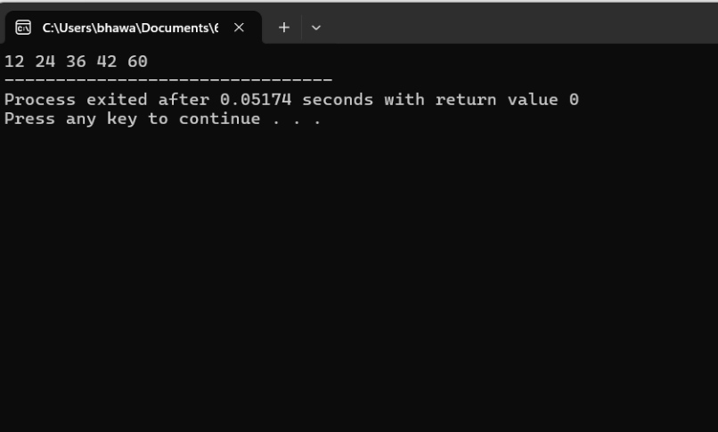
Q3)
//Predict the output
#include<stdio.h>
int main()
{
int i;
int arr[5]={1};
for (i = 0; i<5; i++)
printf( "%d", arr[i]);
return 0;
}
OUTPUT
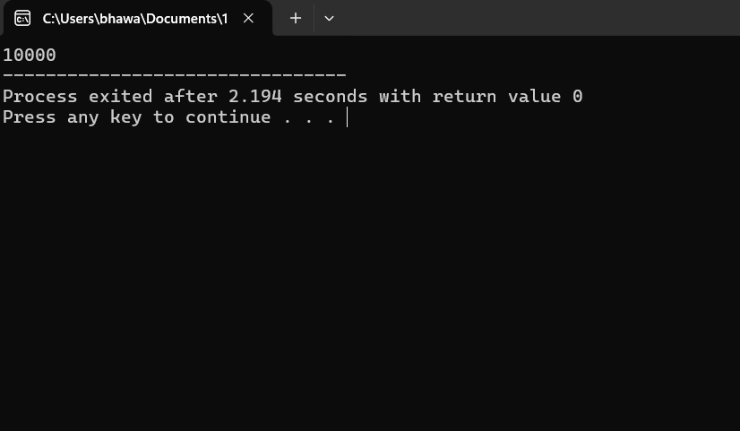

Q4) a
//Program to Reverse elements of an array
#include <iostream>
using namespace std;
int main() {
int n;
cout << "Enter the size of the array: ";
cin >> n;
int arr[n];
cout << "Enter " << n << " elements: ";
for (int i = 0; i < n; i++) {
cin >> arr[i];
}
// Reverse the array
for (int i = 0; i < n / 2; i++) {
int temp = arr[i];
arr[i] = arr[n - i - 1];
arr[n - i - 1] = temp;
}
cout << "Reversed array: ";
for (int i = 0; i < n; i++) {
cout << arr[i] << " ";
}
cout << endl;
return 0;
}
OUTPUT
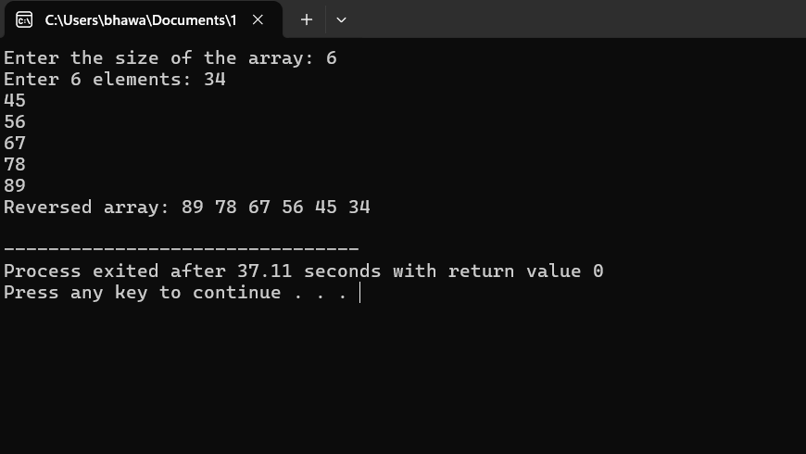

b)
//Program to find the matrix multiplication
#include <iostream>
using namespace std;
#define R1 2 // number of rows in Matrix-1
#define C1 2 // number of columns in Matrix-1
#define R2 2 // number of rows in Matrix-2
#define C2 3 // number of columns in Matrix-2
void mulMat(int mat1[100][C1], int mat2[100][C2])
{
int rslt[R1][C2];
cout << "Multiplication of given two matrices is:\n";
for (int i = 0; i < R1; i++) {
for (int j = 0; j < C2; j++) {
rslt[i][j] = 0;
for (int k = 0; k < R2; k++) {
rslt[i][j] += mat1[i][k] * mat2[k][j];
}
cout << rslt[i][j] << "\t";
}
cout << endl;
}
}
// Driver code
int main()
{
// R1 = 4, C1 = 4 and R2 = 4, C2 = 4 (Update these
// values in MACROs)
int mat1[R1][C1] = { { 4, 4 }, { 6, 6 } };
int mat2[R2][C2] = { { 4, 4, 4 }, { 6, 6, 6 } };
if (C1 != R2) {
cout << "The number of columns in Matrix-1 must "
"be equal to the number of rows in "
"Matrix-2"
<< endl;
cout << "Please update MACROs according to your "
"array dimension in #define section"
<< endl;
exit(EXIT_FAILURE);
}
// Function call
mulMat(mat1, mat2);
return 0;
}
OUTPUT
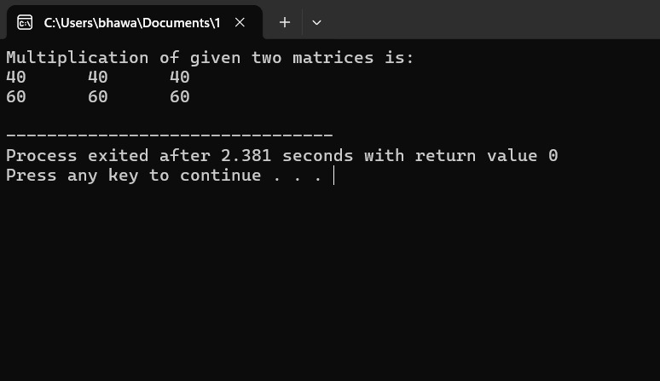

C)
//Program to find transpose of a matrix
#include <iostream>
using namespace std;
// This function stores transpose
// of A[][] in B[][]
void transpose(int A[][N],
int B[][N])
{
int i, j;
for (i = 0; i < N; i++)
for (j = 0; j < N; j++)
B[i][j] = A[j][i];
}
int main()
{
int A[N][N] = {{1, 1, 1, 1},
{2, 2, 2, 2},
{3, 3, 3, 3},
{4, 4, 4, 4}};
int B[N][N], i, j;
transpose(A, B);
cout << "Result matrix is \n";
for (i = 0; i < N; i++)
{
for (j = 0; j < N; j++)
cout << " " << B[i][j];
cout <<"\n";
}
return 0;
}
OUTPUT
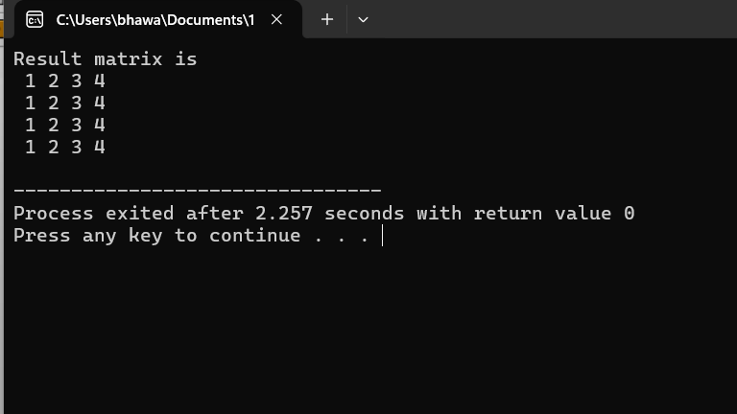

Q5)
//Program to find sum of every row and column in two dimensional array
#include<iostream>
using namespace std;
int main() {
// Define the dimensions of the 2D array
const int ROWS = 3;
const int COLS = 4;
// Declaring and initializing the 2D array
int matrix[ROWS][COLS] = {
{8, 9, 10, 11},
{12, 13, 14, 15},
{16, 17, 18, 19}
};
// Calculate sum of row
std::cout << "Row Sums:" << std::endl;
for (int i = 0; i < ROWS; ++i) {
int rowSum = 0;
for (int j = 0; j < COLS; ++j) {
rowSum += matrix[i][j];
}
std::cout << "Sum of Row " << i + 1 << ": " << rowSum << std::endl;
}
// Calculate sum of columns
std::cout << "\nColumn Sums:" << std::endl;
for (int j = 0; j < COLS; ++j) {
int colSum = 0;
for (int i = 0; i < ROWS; ++i) {
colSum += matrix[i][j]; //To find the missing number in sorted array
#include <iostream>
using namespace std;
int findMissing(int arr[], int n) {
int diff = arr[0]; // Expected difference (since array should be continuous)

for (int i = 0; i < n; i++) {
if (arr[i] - i != diff) {
return i + diff;
}
}
return -1; // No missing element
}
int main() {
int arr[] = {1, 2, 3, 4, 6, 7, 8};
int n = sizeof(arr) / sizeof(arr[0]);

int missing = findMissing(arr, n);
if (missing != -1)
cout << "Missing element is: " << missing << endl;
else
cout << "No element is missing." << endl;
return 0;
}
}
std::cout << "Sum of Column " << j + 1 << ": " << colSum << std::endl;
}
return 0;
}
OUTPUT
